**PRAIA DO CAMILO**

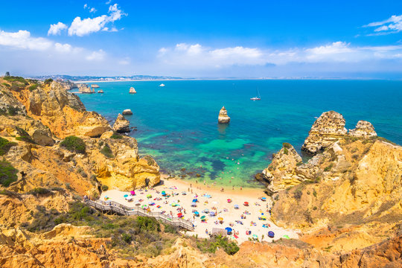Praia do Camilo is a stunning beach located near the city of Lagos in the Algarve region of southern Portugal. It is known for its picturesque setting, characterized by cliffs, rock formations, and crystal-clear turquoise waters. Praia do Camilo is often considered one of the most beautiful beaches in the Algarve.